



**AUTOMATIC LIGHT FAULT DETECTING SYSTEM**

**A MINOR PROJECT - IV REPORT**

***Submitted by***

|  |  |
| --- | --- |
| AAKASH T | (927621BEC001) |
| AJAY RAHUL R | **(927621BEC010)** |
| ATHIL ABDUL RAHIM M  DHARANESWARA V | **(927621BEC016)**  **(927621BEC037)** |

**BACHELOR OF ENGINEERING**

in

**DEPARTMENT OF ELECTRONICS AND COMMUNICATION ENGINEERING**

**M.KUMARASAMY COLLEGE OF ENGINEERING**

(Autonomous)

**KARUR – 639 113**

**MARCH-2024**

**M.KUMARASAMY COLLEGE OF ENGINEERING, KARUR**

**BONAFIDE CERTIFICATE**

Certifiedthatthis **18ECP106L - Minor Project IV** report **“AUTOMATIC LIGHT FAULT DETECTING SYSTEM”** is the bonafide workof “**AAKASH T (927621BEC001), AJAY RAHUL R (927621BEC010), ATHIL ABDUL RAHIM M (927621BEC016) ), DHARANESWARA V (927621BEC037)”** who carried out the project work under my supervision in the academic year **2023-2024 (EVEN SEMESTER).**

**SIGNATURE SIGNATURE**

**Dr.A.KAVITHA B.E., M.E., Ph.D.,** **Dr.T.SENTHIL KUMAR** **M.E, Ph.D.,**

**HEAD OF THE DEPARTMENT, SUPERVISOR,**

Professor, Professor,

Department of Electronics and Department of Electronics and

Communication Engineering, Communication Engineering,

M.Kumarasamy College of Engineering, M.Kumarasamy College of Engineering, Thalavapalayam, Thalavapalayam,

Karur-639113. Karur-639113.

This Minor project-III report has been submitted for the **18ECP106L – Minor Project-IV** Review held at M. Kumarasamy College of Engineering, Karur on **_________________**

**PROJECT COORDINATOR**

**INSTITUTION VISION AND MISSION**

**Vision**

To emerge as a leader among the top institutions in the field of technical education.

**Mission**

**M1:** Produce smart technocrats with empirical knowledge who can surmount global challenges.

**M2:** Create a diverse, fully engaged, learner-centric campus environment to provide quality education to the students.

**M3:** Maintain mutually beneficial partnerships with our alumni, industry, and professional associations

**DEPARTMENT VISION, MISSION, PEOs, POs, AND PSOs**

**Vision**

To empower the Electronics and Communication Engineering students with emerging technologies, professionalism, innovative research, and social responsibility.

**Mission**

**M1:** Attain academic excellence through the innovative teaching-learning process, research areas & laboratories, and Consultancy projects.

**M2:** Inculcate the students in problem-solving and lifelong learning ability.

**M3:** Provide entrepreneurial skills and leadership qualities.

**M4:** Render the technical knowledge and skills of faculty members.

**Program Educational Objectives**

**PEO1:** **Core Competence:** Graduates will have a successful career in academia or industry associated with Electronics and Communication Engineering

**PEO2:** **Professionalism:** Graduates will provide feasible solutions for challenging problems through comprehensive research and innovation in the allied areas of Electronics and Communication Engineering.

**PEO3:** **Lifelong Learning:** Graduates will contribute to the social needs through lifelong learning, practicing professional ethics and leadership quality

**Program Outcomes**

**PO 1: Engineering knowledge:** Apply the knowledge of mathematics, science, engineering fundamentals, and an engineering specialization to the solution of complex engineering problems.

**PO 2: Problem analysis:** Identify, formulate, review research literature, and analyze complex engineering problems reaching substantiated conclusions using first principles of mathematics, natural sciences, and engineering sciences.

**PO 3: Design/development of solutions:** Design solutions for complex engineering problems and design system components or processes that meet the specified needs with appropriate consideration for public health and safety, and the cultural, societal, and environmental considerations.

**PO 4: Conduct investigations of complex problems:** Use research-based knowledge and research methods including design of experiments, analysis and interpretation of data, and synthesis of the information to provide valid conclusions.

**PO 5: Modern tool usage:** Create, select, and apply appropriate techniques, resources, and modern engineering and IT tools including prediction and modeling to complex engineering activities with an understanding of the limitations.

**PO 6: The engineer and society:** Apply reasoning informed by the contextual knowledge to assess societal, health, safety, legal, and cultural issues and the consequent responsibilities relevant to the professional engineering practice.

**PO 7: Environment and sustainability:** Understand the impact of professional engineering solutions in societal and environmental contexts, and demonstrate the knowledge of, and need for sustainable development.

**PO 8: Ethics:** Apply ethical principles and commit to professional ethics and responsibilities and norms of the engineering practice.

**PO 9: Individual and team work:** Function effectively as an individual, and as a member or leader in diverse teams, and in multidisciplinary settings.

**PO 10: Communication:** Communicate effectively on complex engineering activities with the engineering community and with society at large, such as being able to comprehend and write effective reports and design documentation, make effective presentations, and give and receive clear instructions.

**PO 11: Project management and finance:** Demonstrate knowledge and understanding of the engineering and management principles and apply these to one’s own work, as a member and leader in a team, to manage projects and in multidisciplinary environments.

**PO 12: Life-long learning:** Recognize the need for, and have the preparation and ability to engage in independent and life-long learning in the broadest context of technological change.

**Program Specific Outcomes**

**PSO1:** Applying knowledge in various areas, like Electronics, Communications, Signal processing, VLSI, Embedded systems, etc., in the design and implementation of Engineering applications.

**PSO2:** Able to solve complex problems in Electronics and Communication Engineering with analytical and managerial skills either independently or in a team using the latest hardware and software tools to fulfill industrial expectations.

|  |  |
| --- | --- |
| **Abstract** | **Matching with POs, PSOs** |
| **Automation, Navigation, IoT, Cloud storage, Time efficiency.** | **PO1, PO3, PO6, PO7, PO11.** |

**ACKNOWLEDGEMENT**

Our sincere thanks to **Thiru.M.Kumarasamy, Chairman** and **Dr.K.Ramakrishnan, Secretary** of **M.Kumarasamy College of** **Engineering** for providing extraordinary infrastructure, which helped us to complete this project in time.

It is a great privilege for us to express our gratitude to **Dr.B.S.Murugan., B.Tech., M.Tech., Ph.D.,** **Principal** for providing us right ambiance to carry out this project work.

We would like to thank **Dr.A.Kavitha B.E., M.E., Ph.D.,** **Professor and Head**, **Department of Electronics and Communication Engineering** for his unwavering moral support and constant encouragement towards the completion of this project work.

We offer our wholehearted thanks to our **Project Supervisor,** **Dr.T.Senthil Kumar, M.E., Ph.D., Professor**, Department of Electronics and Communication Engineering for his precious guidance, tremendous supervision, kind cooperation, valuable suggestions and support rendered in making our project to be successful.

We would like to thank our **Minor Project Co-ordinator**, **Dr.E.Dinesh, M.E., Ph.D., Associate Professor**, Department of Electronics and Communication Engineering for his kind cooperation and culminating in the successful completion of this project work. We are glad to thank all the Faculty Members of the Department of Electronics and Communication Engineering for extending a warm helping hand and valuable suggestions throughout the project. Words are boundless to thank our Parents and Friends for their motivation to complete this project successfully.

**ABSTRACT**

This project was developed by our team with the main motto of reducing the workload of the electrician and wiring man. The process to rectify the complaint of the defective street light may take a lot of time to point out where the problem occurs. So, in this project, the process can be done in a simple way as the process of finding the defective one is totally automated with an IoT process that points out the location with a GPS module, so the live tracking process can be done easily., the process of finding the location can be done with GPS Module as by sending an SMS of the specified lining street lamp number or by storing the coordinates of the location such as latitude and altitude of the place. Thereby, storing the data in the cloud storage and accessing the location by navigation using maps. So, for the progress of this project, we can use a navigation system thereby, we can enhance the effectiveness of the project and we can also make it a time-efficient process. In modern times, people used to move on with time-efficient processes. So, the reduction in the time period may help people not to suffer a lot from the problems and help the authority to work consistently.

**Keywords:** **GPS Module, SMS, Navigation, IoT, Cloud storage,**

**Time efficient.**

**TABLE OF CONTENTS**

|  |  |  |  |
| --- | --- | --- | --- |
| **CHAPTER No.** | **CONTENTS** | | **PAGE No.** |
|  | **Institution Vision and Mission** | | **iii** |
|  | **Department Vision and Mission** | | **iii** |
|  | **Department PEOs, POs, and PSOs** | | **iv** |
|  | **Abstract** | | **viii** |
|  | **List of Tables** | | **ix** |
|  | **List of Figures** | | **xi** |
|  | **List of Abbreviations** | | **xii** |
| 1 | **INTRODUCTION**   * 1. Outline of the project   2. Scope of the project | | **1**  2  2 |
| 2 | **LITERATURE SURVEY** | | **3** |
| 3  4  5    6      7  8 | **EXISTING SYSTEM**  **PROPOSED SYSTEM**  **HARDWARE DESCRIPTION**  5.1 Power Supply  5.2 Linear Power Supply  5.3 Transformer  5.4 Rectifier  5.5 Regulator  5.6 Relay  5.7 Smoothing  **MODEL AND SYSTEM DEVELOPMENT**  6.1 Introduction  6.2 Resistance  6.3 Protective Diodes  **RESULT AND DISCUSSION**  **CONCLUSION AND FUTURE SCOPE**  **APPENDICES**  **REFERENCES** |  | **6**  **8**  **10**  10  10  11  11  12  12  13  **14**  14  15  15  **16**  **21**  **21**  **22** |
|  |  |  |  |

**LIST OF FIGURES**

|  |  |  |
| --- | --- | --- |
| **FIGURE No.** | **TITLE** | **PAGE No.** |

1. Schematic Diagram 9
2. Block Diagram 11
3. Transformer 11
4. Rectifier 12
5. Regulator 12
6. Relay 13
7. Smoothing 13
8. Protective Diodes 15
9. Project kit 17
10. Arduino booting 19
11. Stage1 detection 19
12. Stage2 detection 19
13. Display output 20

**LIST OF ABBREVIATIONS**

|  |  |  |
| --- | --- | --- |
| S. No | Abbreviation | Expansion |
| 1 | LCD | Liquid Crystal Display |
| 2 | I/O | Input/Output |
| 3 | IDE | Integrated Development Environment |
| 4 | LED | Light Emitting Diode |
| 5  6  7  8  9 | DC  LDR  GSM  IoT  SMS | Direct Current  Light Dependent Resistor  Global System for Mobile Communication  Internet of Things  Short Message Service |

**CHAPTER 1  
 INTRODUCTION**

India is a country where a major chunk of the population is still not connected to the power grid. In order to supply power to them, India will need to create either newer sources of power or reduce the power demand by implementing energy-efficient devices at all levels. Creating a new power supply is a very big task and also involves too much economic investment. So, efficient utilization of electricity is preferred. Global trends in street lighting show that 18-38% of the total energy bill goes towards street lighting and therefore this is one domain that needs major attention if we look at improving the efficiency of power consumption with an objective of saving energy. After midnight there is less requirement of light in the streets as there is no passage of people. We can automate the Street light system to switch off the street lights during the daytime and switch off alternative street lights at midnight. We can save more than 25% of normal consumption using this Smart City specifies a town or city that networks one or several supply systems, controls these via software, and achieves significant savings in resources and costs due to control according to requirements. Power consumption and energy costs can be significantly reduced with "Smartification". Simultaneously, maintenance processes are cut as well as the effort of planning the complete lighting infrastructure and controlling this on a daily basis. InteliLIGHT is a remote street lighting control solution that offers you detailed, lamp-level management capabilities for every street light in your city. We present a novel system - a Smart Street Light Fault Detection System, which utilizes the capabilities of light-dependent resistors (LDRs) to create an energy-efficient and fault-aware street lighting solution. So, we can know, whether it is a power failure or a lamp failure. In that case, GSM automatically sends a message to the control room.

**1.1 Outline of the project**

Currently, in the whole world enormous electric energy is consumed street lights are usually very costly to operate bad control of street lights leads to vehicle accidents. Today street light systems are not flexible most of the control is manual as some are automated based on environmental parameters. The biggest problem is in handling remote area locations manual mistakes result in power wastage. So, there is a need for an efficient street light system to provide wireless access for controlling it. The server which can be used to control the whole city’s street light and low-cost internet technology can be used for remote access. The proposed system controls all the street lights using an Arduino microcontroller This proposed system presents a smart street light fault detection system using two Light Dependent Resistors (LDRs).

**1.2 Scope of the project**

One LDR is employed to monitor the ambient light conditions, and if the environment becomes sufficiently dark, the street light will be automatically switched on. A second LDR is positioned beneath the street light to detect any faults in the street light operation. If the second LDR senses darkness while the street light is supposed to be on, it indicates a potential fault and displays a warning on an LCD display. This system aims to enhance the reliability and efficiency of street lighting systems, providing improved safety and energy conservation. So, efficient utilization of electricity is preferred. Global trends in street lighting show that 18-38% of the total energy bill goes towards street lighting and therefore this is one domain that needs major attention if we look at improving the efficiency of power consumption with an objective of saving energy. After midnight there is less requirement of light in the streets as there is no passage of people.

**CHAPTER 2**

**LITERATURE SURVEY**

**2.1 Design and Fabrication of Small VAWT for Turbine Tree using PVC blades.**

**Author Name:** Manoj M Koushik, Anantha Narayana H B, Gowtham.

**Year of Publication:** IEEE, 2018.

**Discussion:** An existing approach is made to harness the wind energy from moving vehicles on highways, railway tracks, and truck applications to generate electricity. A turbine tree is a concept in which a number of small vertical axis wind turbines (VAWT) are mounted on a single arrangement and coupled to obtain high power output. Presently metals and composites are being used as material for blades in turbines. So, the use of materials other than metals in wind turbines is yet to be researched. Also, the Integration of wind turbines in vehicles and roads is yet to be thoroughly researched and tested.

**2.2 An overview of different methods of Domestic Waste Management and Energy generation in India.**

**Author Name:** **Piyali Mondal.**

**Year of Publication:** IEEE, 2018.

**Discussion:** Domestic wastes are not collected, segregated, and disposed of properly, then is a serious aspect that causes environmental degradation. This problem will also find a solution where we can limit environmental pollution caused due to waste. In this paper, a brief review of municipal solid waste management systems is given which helps in energy generation and can be a step to mitigate energy crisis using developing technology. Also, different methods of energy generation from wastes are described and methods of incineration, Anaerobic Digestion, and Pyrolysis, are described for waste-to-energy (WTE) conversion, and their application in India is also discussed. We still being a developing country, cannot mobilize enough funds for proper collection and segregation of wastes. This becomes a key challenge and needs to find a solution with proper implementation of strict laws and regulations. This also becomes a major cause for the failure of such power plants which run on waste.

**2.3 Simultaneous Wireless Strain Sensing and Energy Harvesting from Multiple Piezo-Patches for Structural Health Monitoring Applications.**

**Author Name:** Huakang Xia, Yinshui Xia.

**Year of Publication:** IEEE, 2018.

**Discussion:** Wireless strain sensing and energy harvesting (SWSSEH) from multiple piezo patches, which is intended for self-powered structural health monitoring (SHM) applications. The EH subsystem is mainly the self-powered extended synchronous electric charge extraction (ECE)interface based on a double cross-coupled rectifying structure and a single fly-back transformer, which is able to harvest energy from multiple piezo patches. The WSS subsystem is mainly the low-power multiplexing analog front end (MAFE), designed to process the multichannel strain signals. The innovation of the proposed approach is that energy harvesting and strain sensing can actually work simultaneously without interfering with each other.

**2.4 Design of Smart LED Streetlight System for Smart City with Web-Based Management System.**

**Author Name:** Philip Tobianto Daely, Haftu Tasew Reda, Gandeva Bayu Satrya.

**Year of Publication:** IEEE, 2017.

**Discussion:** They considered the importance of CCT-based illumination and proposed a novel integration of public weather data awareness, ZigBee-based wireless communication, and dynamic web-based management system for the state-of-art of smart LED streetlight system applicable to smart cities.

**2.5 IOT-based Accident Prevention System using ESP8266.**

**Author Name:** Prakhar Srivastava, Mohit Bajaj.

**Year of Publication:** 2018.

**Discussion:** Weather variables such as fog, frost, and air pollutants have severe consequences on traffic accidents. Decreased driver visibility-related weather risks have critical impacts on traffic accidents. In particular, nowadays, urban areas have experienced traffic accidents that happen due to low visibility effects caused by fog or pollution. We are therefore motivated to develop a weather data-aware smart LED streetlight system in order to detect a driver's blind spot when climate hazards such as too foggy, rainy, snowy, etc.

**2.6 Problem statement**

To develop smart LED streetlight technology, which will be a substantial and appealing input for smart cities using renewable energy. A practical implementation system applicable to public street lighting; giving solution to traffic accidents due to low light of light intensity. Implementing a web-based management system for street lighting opens a new door in terms of dynamic and innovative solutions, advanced control functionality, flexibility through remote access, and improvement of blind spot traffic accidents. Currently, in the whole world enormous electric energy is consumed street lights are usually very costly to operate bad control of street lights leads to vehicle accidents. Today street light systems are not flexible most of the control is manual as some are automated based on environmental parameters. The innovation of the proposed approach is that energy harvesting and strain sensing can actually work simultaneously without interfering with each other.

**CHAPTER 3**

**EXISTING SYSTEM**

**3.1 PLC automated street lightning.**

Automated Street lighting using PLC, Street light controlling using PLC is a novel concept using XD26 PLC controller. In this system manual work is not required. Automatic switch ON and OFF of light in response based on sunlight is done by using LDR, which plays a major role. Effect of seasonal variations; increased energy efficiency; low operating costs low maintenance costs are advantages of this method. The testing and analytics of this project with the accurate operation of the streetlights are done involving Crouzet Millennium software.

**3.2 GSM-based smart street light.**

GSM-based smart street light monitoring and control system is an automated system designed to increase the efficiency and accuracy of an industry by automatically timed controlled switching of street lights they are basically two modules which include the client side and another one is server side. The client side consists of a GSM modem which is further connected to the microcontroller. The server side consists of java Java-based web server.

**3.3 Street light using microcontroller.**

Automatic Street Light Control System Using Microcontroller, This paper aims at designing and executing the advanced development in embedded systems for energy saving of street light systems. These days, human has become too busy and is unable to find time even to switch the lights wherever not necessary. This paper gives the best solution for electrical power expenditure. Also, the manual operation of the lighting system is completely eliminated. In this paper, two sensors are used which are the Light Dependent Resistor LDR sensor to indicate a light or dark time and the photoelectric sensors to detect the movement on the street. The microcontroller PIC16F877A is used as a brain to control the street light system, where the programming language used for implementing the software to the microcontroller is C language.

**3.4 RFID approach.**

GSM-based RFID approach to automatic street lighting system; this system proposes a new way of reducing power utilization. With this system, recovering from a power failure period can be reduced. Street light maintenance, load maintenance and if there are any complaints concerning power it can be warmed through GSM. In the future, the Electricity department can adopt this system in order to save power as well as time. This system can be extended in such a way that time in use for processing any new power connection request can be minimized by using RFID.

**3.5 LDR sensors.**

Automatic Street Lights, this project is all about controlling the power consumption on the streets and eliminating manpower. This includes scheming a circuit of street lights with specific Sensors, LDR, and Microcontrollers during day and night. This requires three basic components i.e., LDR, Sensors, and microcontroller. For the duration of daytime, there is no requirement for street lights so the LDR keeps the street light off until the light point is low or the frequency of light is low and the resistance of the LDR is high. This prevents current from flowing to the base of the transistors. Thus, the street lights do not glow.

**3.6 Intelligent conventional street light.**

Intelligent Street Lighting System Using GSM, Conventional Street lighting systems in areas with a low frequency of passersby are online most of the night without purpose. The consequence is that a large amount of power is wasted uselessly. With the wide availability of flexible-lighting technology like light-emitting diode lamps and an available wireless internet connection, fast react, reliably operating, and power-conserving street lighting systems become actuality. The purpose of this work is to describe the Intelligent Street Lighting (ISL) system, a first approach to accomplish the demand for flexible public lighting systems.

**CHAPTER 4**

**PROPOSED SYSTEM**

Currently, in the whole world, an enormous electric energy is consumed by street lights are usually very costly to operate bad control of street lights leads to vehicle accidents. Today street light systems are not flexible most of the control is manual as some are automated based on environmental parameters. The biggest problem is in handling remote area locations manual mistakes result in power wastage. So, there is a need for an efficient street light system to provide wireless access for controlling it. The server which can be used to control the whole city’s street light and low-cost internet technology can be used for remote access. The LDR situated above the street light is designed to continuously monitor the surrounding light conditions. When the ambient light level drops below a predefined threshold, the system's Arduino controller triggers the street light to automatically switch on. A second LDR is positioned beneath the street light to evaluate its operation. When the street light is expected to be on due to dark ambient conditions (as determined by LDR 1), but LDR 2 detects darkness, it is interpreted as a potential fault. The Arduino controller promptly generates a fault alert, which is displayed on an LCD screen for quick identification and resolution. Currently, in the whole world enormous electric energy is consumed street lights are usually very costly to operate bad control of street lights leads to vehicle accidents. Today street light systems are not flexible most of the control is manual as some are automated based on environmental parameters. The innovation of the proposed approach is that energy harvesting and strain sensing can actually work simultaneously without interfering with each other. In the future, the Electricity department can adopt this system in order to save power as well as time. This system can be extended in such a way that time in use for processing any new power connection request can be minimized by using RFID.

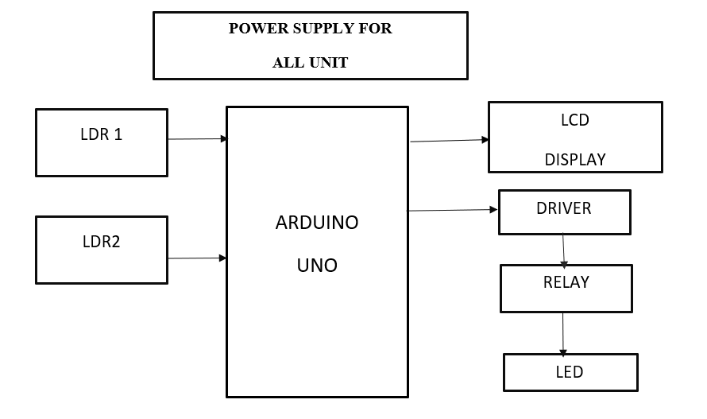

Figure. No. 1. Schematic Diagram

The street lights are ON condition which is shown in Figure. No. 1. But some faulty lights are not glowing. At the time the system found that the lights are not glowing. So, some fault occurs in the light we can know through the LDR values. So, the system sends the alert message to the ward member and ward service man's mobile numbers through the GSM module. At the same time, we can access system status through the cloud storage in anywhere and anytime. Because the street light system connects with cloud storage through the Wi-Fi module as in Figure. No. 1. The Wi-Fi module is used to store the sensor's data in the cloud storage. So, we can access easily the street light system data in the cloud storage. The LDR situated above the street light is designed to continuously monitor the surrounding light conditions. When the ambient light level drops below a predefined threshold, the system's Arduino controller triggers the street light to automatically switch on. A second LDR is positioned beneath the street light to evaluate its operation.

**CHAPTER 5**

**HARDWARE DESCRIPTION**

**5.1 Power Supply**

The power supply is a reference to a source of [electrical power](http://en.wikipedia.org/wiki/Electrical_power). A device or system that supplies [electrical](http://en.wikipedia.org/wiki/Electrical) or other types of [energy](http://en.wikipedia.org/wiki/Energy) to an output [load](http://en.wikipedia.org/wiki/External_electric_load) or group of loads is called a power supply unit or PSU. The term is most commonly applied to electrical energy supplies, less often to mechanical ones, and rarely to others.

Power supplies for electronic devices can be broadly divided into linear and switching power supplies. The linear supply is a relatively simple design that becomes increasingly bulky and heavy for high-current devices; voltage regulation in a linear supply can result in low efficiency. A switched-mode supply of the same rating as a linear supply will be smaller, and is usually more efficient, but will be more complex.

**5.2 Linear Power Supply**

An AC-powered linear power supply usually uses a [transformer](http://en.wikipedia.org/wiki/Transformer) to convert the voltage from the wall outlet (mains) to a different, usually a lower voltage. If it is used to produce [DC](http://en.wikipedia.org/wiki/Direct_current), a [rectifier](http://en.wikipedia.org/wiki/Rectifier) is used. A [capacitor](http://en.wikipedia.org/wiki/Capacitor) is used to smooth the pulsating current from the rectifier. Some small periodic deviations from smooth direct current will remain, which is known as a [ripple](http://en.wikipedia.org/wiki/Ripple_(electrical)). These pulsations occur at a frequency related to the AC [power frequency](http://en.wikipedia.org/wiki/Utility_frequency) (for example, a multiple of 50 or 60 Hz).

The voltage produced by an unregulated power supply will vary depending on the load and variations in the AC supply voltage. For critical electronics applications, a [linear regulator](http://en.wikipedia.org/wiki/Linear_regulator) will be used to stabilize and adjust the voltage. This regulator will also greatly reduce the ripple and noise in the output direct current. Linear regulators often provide current limiting, protecting the power supply and attached circuit from overcurrent as denoted in Figure. No .2.

Adjustable linear power supplies are common laboratory and service shop test equipment, allowing the output voltage to be set over a wide range. For example, a bench power supply used by circuit designers may be adjustable up to 30 volts and up to 5 amperes output. Some can be driven by an external signal, for example, for applications requiring a pulsed output.

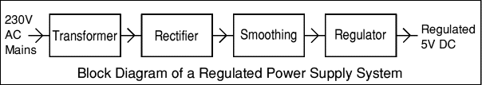

Figure. No. 2. Block Diagram

**5.3 Transformer**



Figure. No. 3

### Transformers convert AC electricity from one voltage to another with little loss of power. Transformers work only with AC, which is one reason why mains electricity is AC. As, Figure. No. 3 shows the simple representation of transformer.

### Step-up transformers increase voltage, step-down transformers reduce voltage. Most power supplies use a step-down transformer to reduce the dangerously high mains voltage (230V in the UK) to a safer low voltage.

**5.4 Rectifier**

There are several ways of connecting diodes to make a rectifier to convert AC to DC as shown in Figure. No. 4. The bridge rectifier is the most important and it produces full-wave varying DC. A full-wave rectifier can also be made from just two diodes if a center-tap transformer is used, but this method is rarely used now that diodes are cheaper. A single diode can be used as a rectifier but it only uses the positive (+) parts of the AC wave to produce half-wave varying DC which is shown in Figure. No. 4.

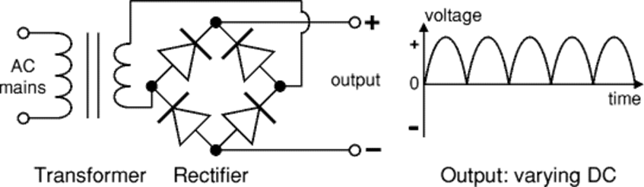

Figure. No. 4. Circuit Diagram

**5.5 Regulator**

### Voltage regulator ICs are available with fixed (typically 5, 12, and 15V) or variable output voltages which is represented in Figure. No. 5. They are also rated by the maximum current they can pass. Negative voltage regulators are available, mainly for use in dual supplies. Most regulators include some automatic protection from excessive current ('overload protection') and overheating ('thermal protection').

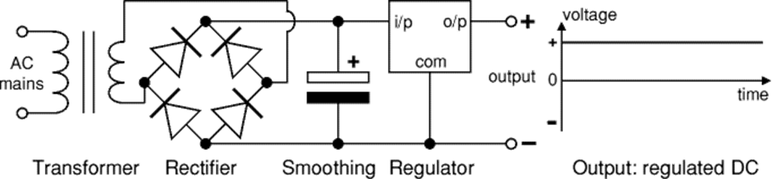

Figure. No. 5. Circuit Diagram

**5.6 Relay**

A relay is an electrically operated switch which is shown in Figure. No. 6. Current flowing through the coil of the relay creates a magnetic field which attracts a lever and changes the switch contacts. The coil current can be on or off so relays have two switch positions and most have double throw (changeover) switch contacts as shown in the diagram. regulators are available, mainly for use in dual supplies. Automatic protection from excessive current ('overload protection') and overheating.

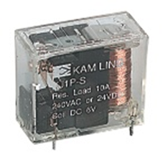

Figure. No. 6. Relay

**5.7 Smoothing**

Smoothing is performed by a large value electrolytic capacitor connected across the DC supply to act as a reservoir, supplying current to the output when the varying DC voltage from the rectifier is falling. The diagram in Figure. No. 7 shows the unsmoothed varying DC (dotted line) and the smoothed DC (solid line). The capacitor charges quickly near the peak of the varying DC, and then discharges as it supplies current to the output.

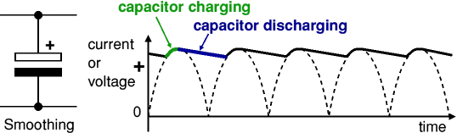

Figure. No. 7. Smoothing

Note that smoothing significantly increases the average DC voltage to almost the peak value (1.4 × RMS value). For example, 6V RMS AC is rectified to full wave DC of about 4.6V RMS.

**CHAPTER 6**

**MODEL AND SYSTEM DEVELOPMENT**

**6.1 Introduction**

It is relatively easy to understand the basics of how an LDR works without delving into complicated explanations. It is first necessary to understand that an electrical current consists of the movement of electrons within a material. Good conductors have a large number of free electrons that can drift in a given direction under the action of a potential difference. Insulators with a high resistance have very few free electrons, and therefore it is hard to make the them move and hence a current to flow.

An LDR or photo resistor is made any semiconductor material with a high resistance. It has a high resistance because there are very few electrons that are free and able to move - the vast majority of the electrons are locked into the crystal lattice and unable to move. Therefore, in this state there is a high LDR resistance.

As light falls on the semiconductor, the light photons are absorbed by the semiconductor lattice and some of their energy is transferred to the electrons. This gives some of them sufficient energy to break free from the crystal lattice so that they can then conduct electricity. This results in a lowering of the resistance of the semiconductor and hence the overall LDR resistance.

The process is progressive, and as more light shines on the LDR semiconductor, so more electrons are released to conduct electricity and the resistance falls further.

LDRs are very useful components that can be used for a variety of light sensing applications. As the LDR resistance varies over such a wide range, they are particularly useful, and there are many LDR circuits available beyond any shown here. In order to utilize these components, it is necessary to know something of how an LDR works, which has been explained above

**6.2 Resistance**

The circuit must be able to supply the current required by the relay coil. You can use [Ohm's law](http://www.kpsec.freeuk.com/ohmslaw.htm) to calculate the current:

|  |  |
| --- | --- |
| Relay coil current   = | supply voltage |
| coil resistance |

For example: A 12V supply relay with a coil resistance of 400 Ohm passes a current of 30mA. This is OK for a 555 timer IC (maximum output current 200mA), but it is too much for most ICs and they will require a [transistor](http://www.kpsec.freeuk.com/trancirc.htm#ic) to amplify the current.

**6.3 Protection Diodes**

Transistors and ICs must be protected from the brief high voltage produced when a relay coil is switched off. The diagram in Figure. No. 8 shows how a signal [diode](http://www.kpsec.freeuk.com/components/diode.htm) (eg.1N4148) is connected 'backwards' across the relay coil to provide this protection.

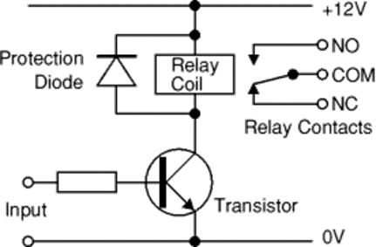

Figure. No. 8

Current flowing through a relay coil creates a magnetic field which collapses suddenly when the current is switched off. The sudden collapse of the magnetic field induces a brief high voltage across the relay coil which is very likely to damage transistors and ICs. The protection diode allows the induced voltage to drive a brief current through the coil (and diode) so the magnetic field dies away quickly rather than instantly. This prevents the induced voltage becoming high enough to cause damage to transistors and ICs.

**CHAPTER 7**

**RESULT AND DISCUSSION**

The proposed automatic street light system utilizing the LDR, Arduino microcontroller, offers several advantages over traditional street lighting systems. The system effectively controls street lights based on ambient light conditions, detects faults, and provides timely notifications for maintenance. The centralized control server and remote access capabilities facilitate efficient management and reduce manual errors. The system's scalability, adaptability, and wireless nature make it suitable for various locations, including remote areas. Overall, the system improves safety, reduces energy consumption, and enhances cost savings. Further research and testing are recommended to validate the system's performance, reliability, and scalability in real-world scenarios, taking into account factors such as weather conditions, power supply stability, and network connectivity. The project has scope in various other applications like as providing lighting in industries, campuses, and parking lots of huge shopping malls. This can also be used for surveillance in corporate campuses and industries. An automatic street light control and fault detection system with cloud storage in this paper, controls the street light ON/OFF automatically depending on the environmental situation and we can easily identify the light faults in this system easily also the system sends an alert message to the authorized person’s mobile numbers. We can monitor the system anywhere and anytime via a cloud storage system. This system is very useful to Municipal Corporations. In, Future we will find the sensor’s faults and power supply faults in the system and also, we will control the light power adjustment depending on the environment. The innovation of the proposed approach is that energy harvesting and strain sensing can actually work simultaneously without interfering with each other. In the future, the Electricity department can adopt this system in order to save power as well as time.

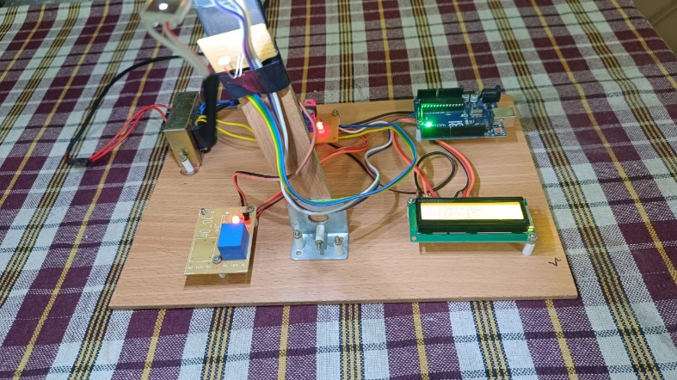

Figure. No. 9

The above picture Figure. No. 9 show off the project prototype and the displayed components. There are multiple stages in the working of the street light project. The first stage is the booting up of the Arduino board and the program.

**SOURCE CODE:**

#include<LiquidCrystal.h>

LiquidCrystal lcd(8,9,10,11,12,13);

int ldr1,ldr2;

int a=0;

void setup() {

// put your setup code here, to run once:

pinMode(A0,INPUT);

pinMode(A1,INPUT);

pinMode(7,OUTPUT);

lcd.begin(16,2);

lcd.setCursor(3,0);

lcd.print("Welcome");

delay(3000);

lcd.clear();}

void loop() {

// put your main code here, to run repeatedly:

ldr1=(analogRead(A0)/10);

ldr2=(analogRead(A1)/10);

lcd.clear();

lcd.setCursor(2,0);

lcd.print("LDR1=");

lcd.setCursor(7,0);

lcd.print(ldr1);

lcd.setCursor(2,1);

lcd.print("LDR2=");

lcd.setCursor(7,1);

lcd.print(ldr2);

delay(2000);

if(ldr2<=30){

digitalWrite(7,HIGH);

a=1;}

else {

a=0;

digitalWrite(7,LOW);}

if((a==1)&&(ldr1<30)){

a=0;

lcd.clear();

lcd.setCursor(1,0);

lcd.print("street light");

lcd.setCursor(4,1);

lcd.print("fault");

delay(3000);

}

}

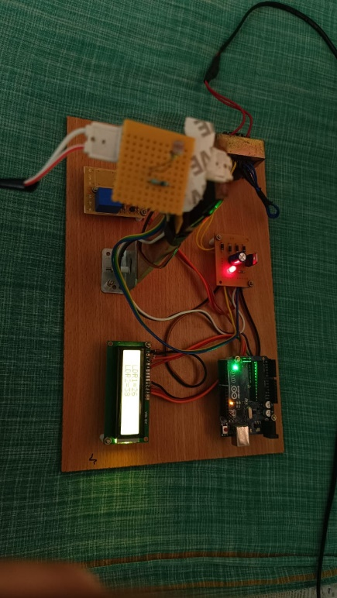 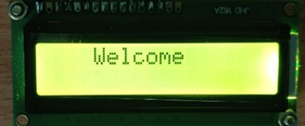

Figure. No. 10

The initial stage of the booting of Arduino board is done and is displayed in Figure. No. 10 and after that the stage 1 is the detection of the sun light by using LDR1 and then if no sun light is found the light will switch on and the reading will be shown in the LCD display.

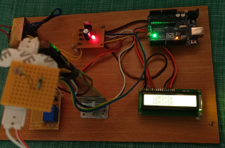 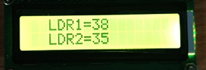

Figure. No. 11

The street light will switch on automatically and then the connection will be given to LDR2 it detects the presence of light in the street lamp and displays the intensity of light which is shown in Figure. No. 11. If there is detection of light then there will be no changes the loop statement in the program moves on running in the background.

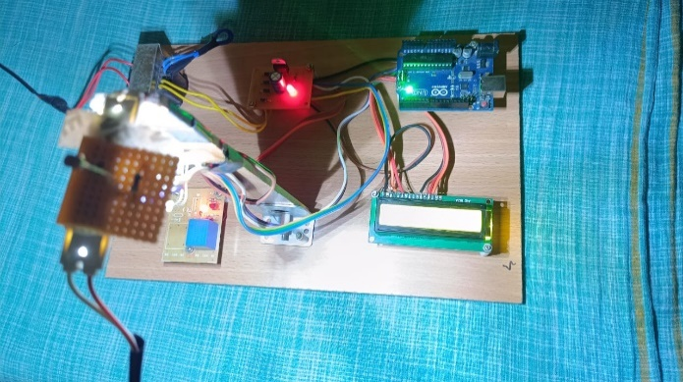 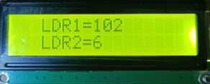

Figure. No. 12

It moves on to detect the light in the LDR2, if there is no detection of light in the LDR2 then the report will be automatically sent to the authority by the use of GSM module and the intensity is shown in the Figure. No. 12.

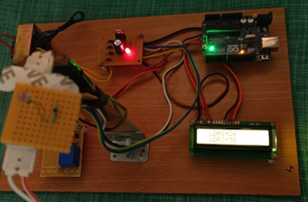 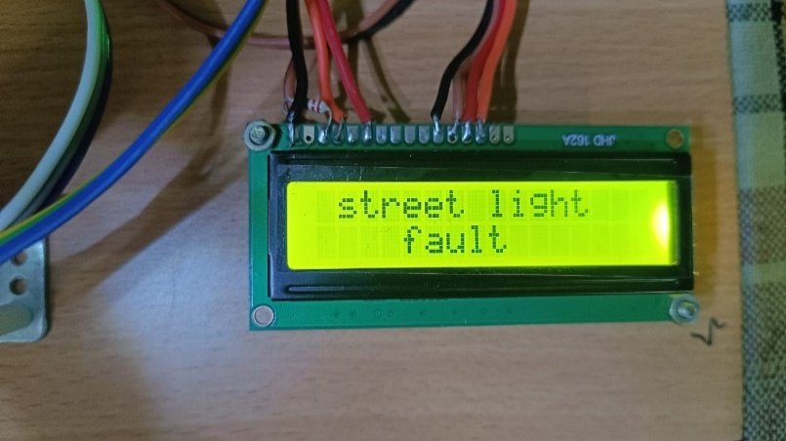

Figure. No. 13

When the LDR2 detects the absence of intensity in the street lamp it will automatically show that the street light is faulty as shown in the Figure. No. 13. After this the message will be automatically sent to the authority by the GSM module.

**CHAPTER 8**

**CONCLUSION AND FUTURE SCOPE**

This paper describes the system that controls the illumination of light; it saves energy and achieves higher efficiency which helps in building a smart city, using Solar panel solar energy will be converted into electrical energy hence power consumption will be very low. Automatically switch ON lights when sunlight goes below the visible region and automatically switch OFF lights when sunlight comes, visible to our eyes. The system explains how to design and build an automatic lighting control system. The desired electronic system overcomes the shortcomings of previous technologies. Based on the results, the microcontroller calculates and automatically recognizes the presence and movement of people, vehicles, and animals through which the intensity changes and guarantees that the lighting system operates in a very exact ON/OFF mode. In no activity situation in the area.

**APPENDICES**

Nowadays resources (water, power, air, etc.) are very precious. This work focused on protecting one such resource energy. Electricity is one of the major losses of energy. Using IoT the street lights ON/OFF is automated based on the weather conditions, and the working status of the street light is observed. The LDR sensor senses the environmental changes, the ON/OFF of the street lights is made automatically. Whenever the street light gets damaged or not on during night time, the LDR sensor senses it and sends the notification to the authorized person that the light is damaged and the location (using GPS) where the light is damaged. It reduces human efforts, and delays in fixing the issues. The automatic control of street lights is used to find the exact location when the street light gets damaged. Further, this can be implemented for all the street lamps in rural lamps. Pre-identification of damaged street lights is done based on the expiry of lamps.

**REFERENCES**

[1] Fabio Leccese, Marco Cagnetti, and Daniele Trinca (2014), “A Smart City

Application: A Fully Controlled Street Lighting Isle Based on Raspberry-Pi

Card, a ZigBee Sensor Network and Wi-Max”, Sensors 2014.

[2] Noriaki Yoshiura and Naoya Ohta (2013), “Smart Street Light System Looking

Like Usual Street Light based on Sensor Networks”, IEEE International

Symposium on Communication and Information Technology.

[3] Wu Yue, Shi Chang Hong (2010), “Design of New Intelligent Street Light

Control System”, IEEE International Conference on Automation.

[4] Saravanan V, Karthikeyan M (2014), “Cloud Based Automation Street Light

Monitoring system”.

[5] Rodrigo Pantoni, Cleber Fonseca, and Dennis Brandao, “Street Lighting System

Based on Wireless Sensor.

[6] D. A. Devi and A. Kumar, Design and Implementation of CPLD based Solar

Power Saving System for Street Lights and Automatic Traffic Controller,

International Journal of Scientific and Research Publications, Vol. 2, Issue11,

November 2012

[7] Mr. Amey J.Manekar, Dr. R .V. Kshirsagar ” Design and Implementation of

Automatic Street Light Controller for Energy Optimization Using FPGA”,

International Journal of Advanced Research in Computer and Communication

Engineering Vol. 5, Issue 6, June 2016.

[8] Chaitanya Amin, AshutoshNerkar, Paridhi Holani, Rahul Kaul” GSM Based

Autonomous Street Illumination System for Efficient Power Management”

International Journal of Engineering Trends and TechnologyVolume4Issue1-

2013.

[9] Abdul Latif Saleem, Raja Sagar R, Sachin Datta N S, Sachin H S,Usha M S

“Street Light Monitoring and Control System” International Journal of

Engineering and Techniques - Volume 1 Issue2, Mar – Apr 2015.

[10] K.Y.Rajput, Gargeyee Khatav, Monica Pujari, Priyanka Yadav” Intelligent

Street Lighting System Using Gsm” International Journal of Engineering

Science Invention Volume 2 Issue 3, March 2013.

[11] V.Sumathi, A. Krishna Sandeep, B.Tarun Kumar “Arm Based Street Lighting

System with Fault Detection” International Journal of Engineering and

Technology- Vol 5 No 5 Oct-Nov 2013.

[12] An Intelligent System for Monitoring and Controlling of Street Light using

GSM Technology, Ms. Swati Rajesh Parekar, Prof. Manoj M. Dongre, 2016,

International Conference on Information Processing.

[13] Self-Cleaning Control System for PV Solar Panel Street Light, Falah Mustafa,

Adeel Abd Sahb, A. Salam Al-Ammri, Areej Ghazi, 2015, IREC.